Project Report Template

JOB APPLICATION TRACKING SYSTEM

1 INTRODUCTION

* 1. Overview
  2. The hiring process can be a time consuming and frustrating experience for employers as well as job seekers.To streamline the process,many companies have started using applicant traciking system(ATS).

1.2Purpose

The use of this project : An ATS creates oppourtunites to automate manual processes, increase visiblittyino to the hiring cycle for the entire recruiting team, and increase opportunities for communication throughtout the candidate journey.78% of recruiters using an ATS report that it has improved the quality of the candidates they hire.

Archieved in ATS: *Streamlines recruiting. growing businesses often end up recruiting for multiple positions at the sametime * Manages talent database.

2 PROBLEM DEFINITION & DESING THINGING

2.1 Empathy map

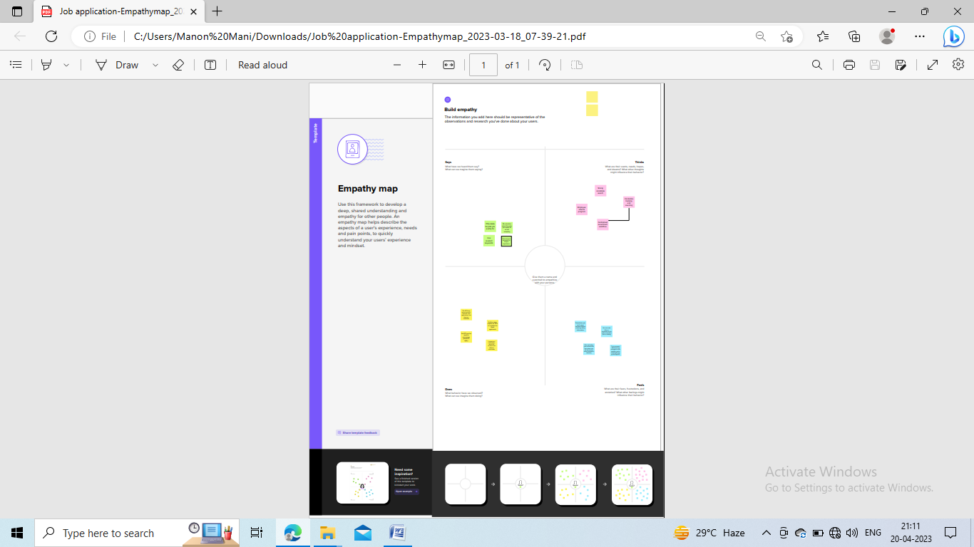

2.2 Ideation & Brainstroming

Ideation

|  |
| --- |
| brainstoming.png |
|  |
|  |

3 RESULT

3.1 Data model

|  |  |
| --- | --- |
| Object name | Fields in the object |
| Profile | |  |  | | --- | --- | | Field label | Data type | | Sales manager | Standered User | | Dhanam | Standed User | |
| New Custom Object | |  |  | | --- | --- | | Field label | Data type | | Candidate | Open the standered salesforce .com help & Training window | | Job | Open the standered salesforce .com help & Training window | |
| Sharing Rules | |  |  | | --- | --- | | Field lable | Data type | | Hr manager | Based on record owner | | Candidate | Based on criteria | |

3.2 Activity & Screenshot

Activity 1-Create A Custom Object

Creating a custom object for Recruiter

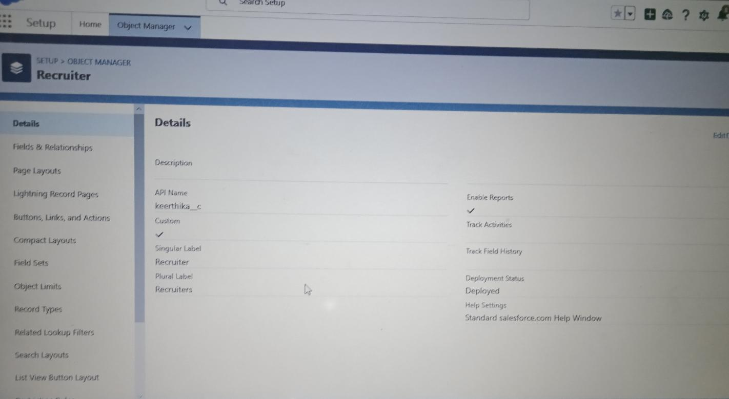

Activity - 1 Create A Candidate

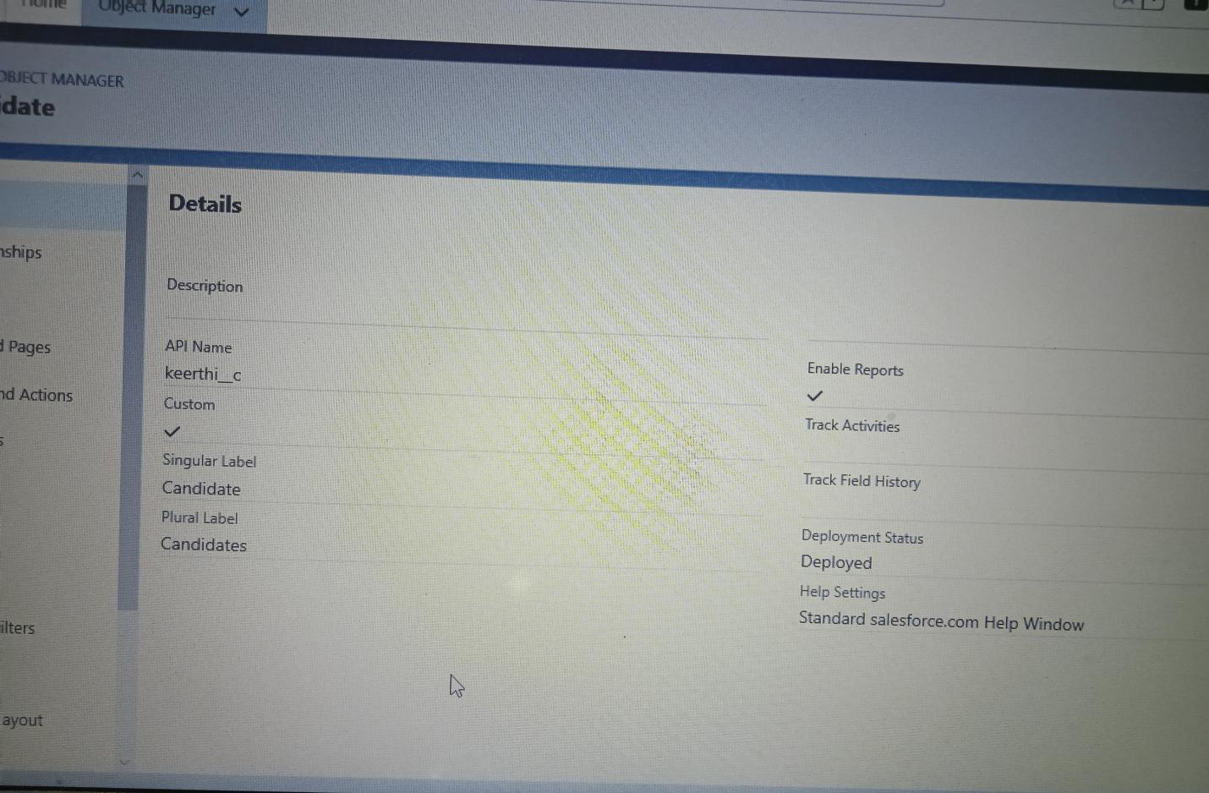

Activity 2 - Create A Custom Profile

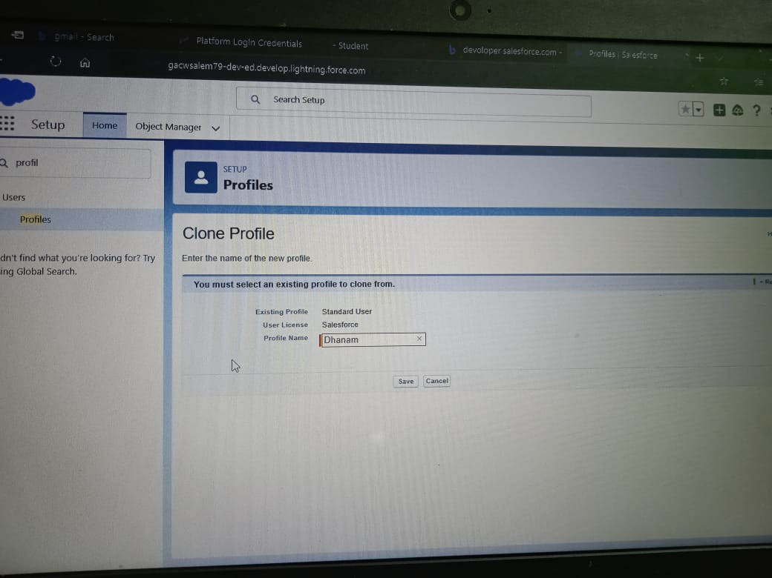

Activity 2 - Create a custom object with the profile neme As “ Sales Manager “

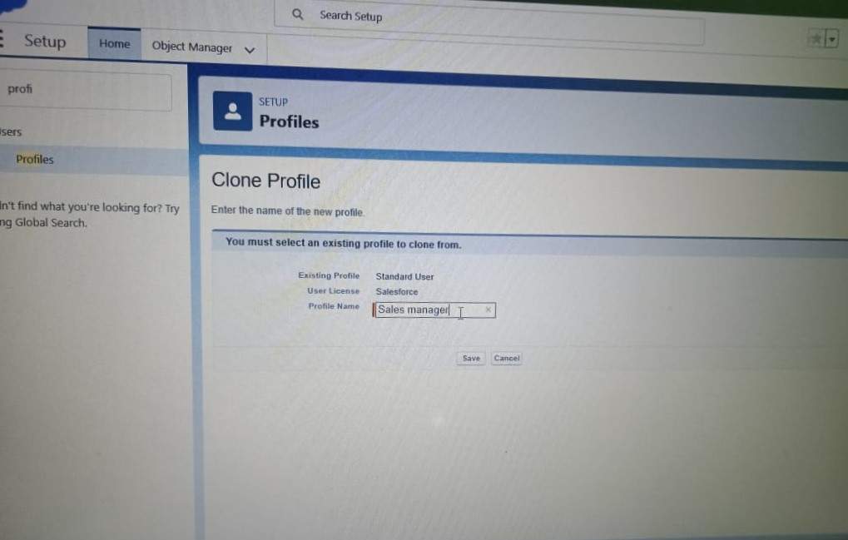

Activity - To Create A User

Create A User With A Username As “ Ganash Gelli “

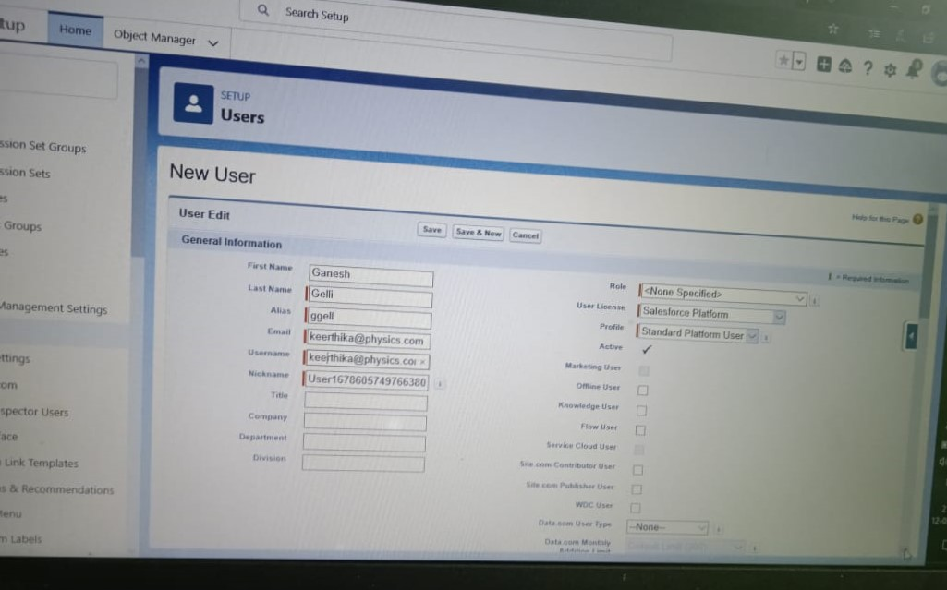

Activity - Sharing Rules

Create a sharing rule

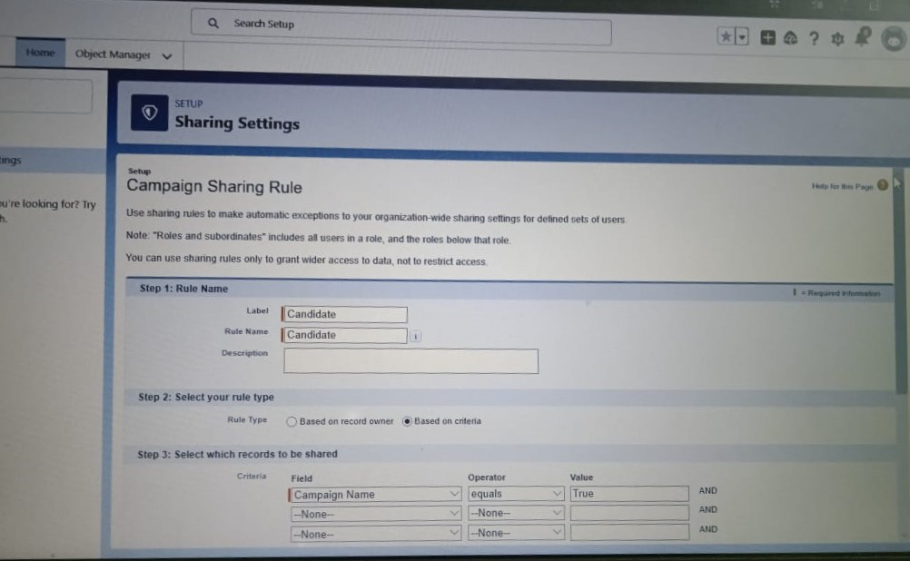

Create a sharing rule to share the records of job applications to HR Manager

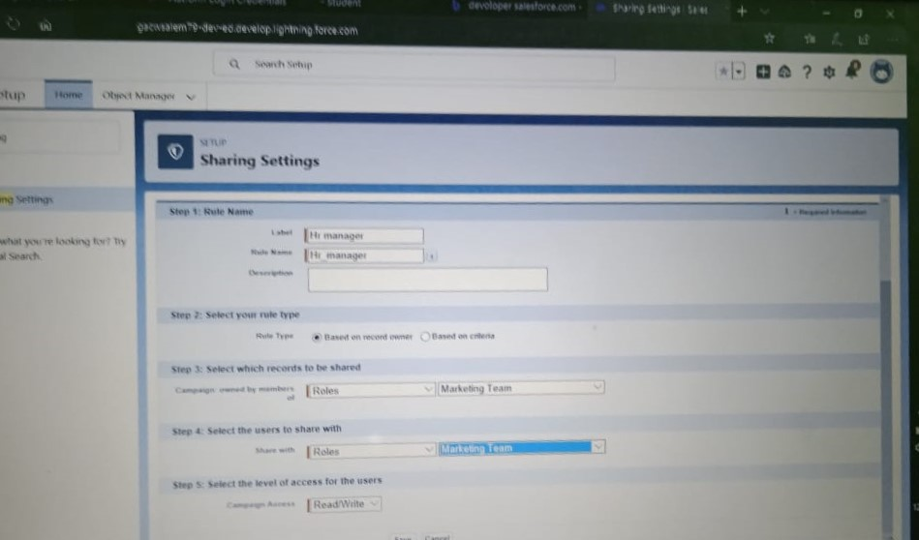

4 Trailhead profile public URL

Team Lead – <https://trailblazer.me/id/kchlm>

Team Member 1-https://trailblazer.me/id/kancv

Team Member 2-https://trailblazer.me/id/mmanonmani

Team Member 3-https://trailblazer.me/id/lchinnaiyan

Project Report Template

5 ADVANTAGES & DISANVATAGES

[ ADVANTAGES ]

1. ****Reduces time spent on admin tasks.**** ATS software allows you to automate various tasks of the hiring process that can save you a lot of time and free up your recruiting personnel for other high-value tasks. Posting to multiple job boards, tracking candidate applications, notifying candidates individually, and scheduling interview feedback can all be automated. Not only will it speed up the time it takes to do all of those tasks, it will increase the overall quality through standardization.
2. ****Resume and CV screening.**** With recruiters receiving 100s of resumes per role, even scanning can take a lot of time. ATS software can be utilized to review applications and filter out candidates that don’t meet the minimum requirements of the role. So, the number of resumes a recruiter needs to review can be reduced drastically using pre-screening questions or word searches within resumes. Once again, a recruiter’s time can be redirected to higher value items of the business.
3. ****Speeds up the recruitment cycle.**** Having candidates’ information centralized on a single platform gives recruiters access to organized information allowing them to review and compare candidates more easily and quickly, which leads to a lower cost-per-hire. All communications, including notes, interviewer ratings, cases, and more can be stored and viewed in one location, which simplifies and speeds up the evaluation process.
4. ****Improves the quality of hire.**** Not only do ATS’s create more efficient workflows, as previously discussed, they can also improve the quality of your hire. First, you were able to cast a wider net by posting on job boards with standardized messaging to attract more candidates. Second, you used automated matching and filtering weed out unqualified candidates. Both benefits saved you or your recruiter the time necessary to deeply evaluate candidates and gather more insightful information so they can communicate with stakeholders and make a well-informed decision. In the end, the entire process was strengthened.
5. ****Enhances reporting and compliance.**** Lack of compliance in the recruiting process can devastate your business and brand. Recruiting software can help keep you stay compliant by standardizing the hiring procedures and communications. In the end, you’ll still need to create compliant standards initially, then everyone using the software will adhere to those guidelines. With all relevant in one place, reporting on recruiting performance or adherence to compliance standards becomes very simple. Automated dashboards provide management with a good view of recruiting performance.
6. ****Boosts your brand.**** Having a streamlined recruiting workflow and messaging can enhance the candidate experience can make a great first impression as you’re trying to attract top-notch talent.
7. ****Improves onboarding.**** As an extension of the recruiting process, onboarding can be streamlined as well. Once you find the right candidate, you want to onboard them as quickly as possible so they can focus on improving your business. Things like tax forms, new hire packets, IT setup requests, and more can be centralized to create a great onboarding experience for your new hire.

## **Disadvantages of Applicant Tracking Systems**

* ****Could filter out good candidates.**** When “programming” your recruiting software to recognize common keywords around roles and responsibilities, you could end up filtering out good candidates that have atypical experience or lack keywords that are aligned with what you are looking for. Careful consideration of your filters and a quality assurance process will help to fine tune the filter and reduce filtering out good candidates. This can happen with manual reviews as well, so automation, in most situations, has a net benefit.
* ****Communications can be less personalized.**** When automating responses to candidates, your messaging will be less personalized and can come off as robotic. Taking additional time to construct good communication can help make it feel more personalized. It’s much better to send a less personalized communication than no communication at all.

APPLICATIONS

* Application 1 : Candidate sourcing

* Application 2 : Job distribution

* Application 3 : Candidate engagement

* Application 4 : Candidate management

* Application 5 : Easy interview scheduling

* Application 6 : Filters candidates

CONCLUSION

Applicant Tracking System for recruiters is a very effective hiring solution that most of the successful recruiters utilize. Because without it, there is a good chance that your process of moving applicants through different stages can become very difficult.

FUTURE SCOPE

The world is moving into automation and AI, and leads way to the new age Applicant Tracking System(ATS). Read further to understand what the future might be like for the ATS.

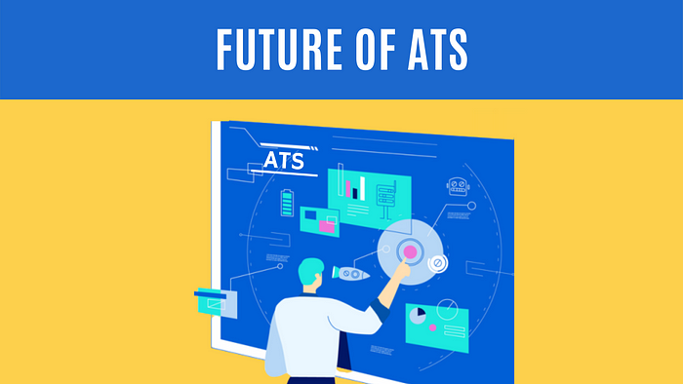

[Future of ATS](https://aviahire.com/index.html" \t "https://medium.com/aviahire/_blank)

The world knows that Applicant Tracking Systems (ATS) made their way into the recruitment domain just a few years ago. Although, previously, ATS solutions were implemented only by a few companies that could bear the heavy investment costs, now their use in the HR arena has risen to a great extent. According to a recently released [survey report](https://www.naukrirms.com/blog/author/naukrirms/" \t "https://medium.com/aviahire/_blank), the majority of staffing firms worldwide will opt for an Applicant Tracking System by the end of 2020 to improve the overall talent acquisition efficacy, in this scope the future of ATS definitely looks bright.

Read on to find out more about the evolution of Applicant Tracking Systems and how the same has been beneficial for the new breed of recruiters.

## **Traditional Applicant Tracking System**

Until a few years, staffing agencies were all using their manual expertise or outdated tools to track potential candidates for vacant positions. Even if few agencies used ATS tools, they would use it only to post job ads to job boards or social channels manually. In addition, the agencies would manually go through all the job boards and candidate databases, and call them individually to inform them about the posting or set up interview dates and times. It was highly time-consuming and tiring. The productivity level was too low as compared to today’s automated and intelligent ATS.

## **Modern Applicant Tracking System**

Leaving tradition behind, the recruitment-technology domain has added new aspects and innovative features, making [ATS](https://aviahire.com/" \t "https://medium.com/aviahire/_blank) the core of the recruitment industry. It has embraced multiple processes of accessing and distributing in genres like social networking via Whatsapp and video conferencing. Given all these developments and innovations, it has become extremely easy for an HR leader to stay up to date.

Let’s have a sneak peek at the improvements that ATS has brought in recent years that have reached the next level of excellence and automation.

# **Features of modern ATS**

## **ATS Will Begin to Look and Act More Like Social Network**

For a long time, ATS was stuck in the “call” with the client phase, representing candidates as little more than names and tokens of information. Now, however, the ATS is entering its Linkedin and other social media phase, ATS will begin to look and act more Like a Social Network.

As more and more people rail against the ATS’s overemphasis on keywords and are finding ways to present fuller pictures of candidates as human beings. Soon enough, a candidate’s presence in an ATS will be more like a portfolio than a traditional ATS database. Candidates will be able to upload their photos, and of course, explain their experiences and qualifications in much more detail.

## **Applicant Tracking Systems have become more user-friendly**

It is a known fact that Applicant Tracking Systems have now become more user-friendly and recruiters do not have to undergo any specific training course to make effective use of them. Modern-day ATS solutions feature a highly effective user interface along with simple-to-use control buttons to ensure that HR professionals can easily create efficient workflows and keep a constant check on the hiring process without any difficulty.

## **There is a rise in AI-based Applicant Tracking System**

HR professionals worldwide have begun harnessing the power of AI-powered Applicant Tracking Software to optimize the efficiency of their recruitment process. Unlike previously, ATS software-driven by AI is making it easier for recruiters to navigate tasks like live interview scheduling, Feedback mechanism, and enabling them to give better job recommendations, thereby giving a noteworthy boost to their hiring endeavors. This way modern-day HR managers can easily source exceptionally skilled passive job candidates, fill vacant positions faster, and significantly remove bias from the hiring process.

## **Applicant Tracking Software now have deep integration capabilities**

Nowadays, the majority of ATS solutions come packed with excellent deep integration capabilities to ensure better functionality around the clock. The best part about an [integrated ATS solution](https://aviahire.com/integrations.html" \t "https://medium.com/aviahire/_blank) is that it reduces the total amount of time spent onboarding new workers and gives deeper insights to human resources personnel that they can use to make improvements in the hiring process. Integration prepares the way for continuous recruiting workflows and helps human resources professionals to remove bottlenecks from the talent acquisition process for producing favorable business outcomes at the earliest possible time.

## **There is a rise of cloud-based ATS solutions**

There was a time when ATS solutions were installed on the company’s system and accessibility was limited only to a couple of users. But with the rise of modern-day technologies in the hiring landscape, most Applicant Tracking Systems are now based in the Cloud. Since the software is hosted virtually, this paves the path for improved flexibility as the solution can be accessed from any location in the globe as long as you have a steady internet connection.

## **ATS Will Turn Rejected Talents into Future Hires Analytics**

The problem with this setup is that there is an assumption that a candidate who isn’t right at this moment won’t be right later on down the line. Many recruiters are already challenging this supposition by nurturing [talent pools](https://medium.com/aviahire/benefits-of-managing-robust-talent-pool-7144639b47d8), which serve as pre-filled talent pipelines. By maintaining relationships with high-quality candidates in the long term, recruiters can more easily find the best talent when positions open up in the future.

# **Conclusion**

In an age where the recruiting world is witnessing rapid technological innovations, it would not be wrong to say that the new generations of [Applicant Tracking Systems](https://aviahire.com/" \t "https://medium.com/aviahire/_blank) powered by Artificial Intelligence (AI) have emerged as an essential tool for the present-day recruiters looking to drive innovative hiring results. Besides making it simpler for hiring managers to track prospective applicants and precisely match resumes with vacant posts for determining the best fit for the job role, ATS solutions can also work wonders for nurturing recruitment campaigns. Above all, make sure that you pick out the most up-to-date recruitment software for your organization so as to get rid of serious manual inefficacies and expedite the entire talent acquisition process in a minute.